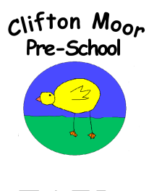
Let’s celebrate your child’s
Interests and Events at Home
Every child is unique and at Clifton Moor Pre-School we love to celebrate everybody’s differences, to help us do this we would like your help and support.
We observe your child whilst they play and take opportunities to introduce new skills and ideas. We would really love to hear about their involvements, experiences and interests at home.
Please could you help us by completing this form (you could include a photo, this will be put into your child’s Learning Journal).
Thank You for your help and support.
Does your child have any current interests or favourite things they like doing at home?
Are they any events happening in your family at the moment?
Is there any other information that would be beneficial for us to know?
Do you have any questions for us?

