Ideas for a Healthy Lunch Box

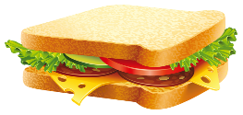
- A Sandwich, Wrap, Bagel, Roll, Chapatti, Pasta or Crackers.
This Photo by Unknown Author is licensed under CC BY-NC
A choice of filling – Chicken, Cheese, Ham or Tuna.

- A Portion of Fruit or Vegetables –
Strawberries, Grapes (cut vertically), Kiwi, Melon,
Carrot, Peppers, Cherry Tomatoes (cut) or Raisins.
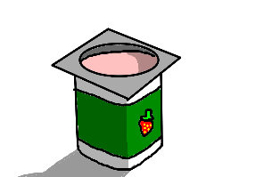
This Photo by Unknown Author is licensed under CC BY-ND
- A Dairy Choice –
Fromage Frais, Yogurt or Cheese.

- A Healthy Extra –
Malt Loaf, Biscuit, Small Cake Bar or Plain Popcorn.
- A Drink –
No Added Sugar Squash or Water.

